- Find the total surface area of the rectangular prism:

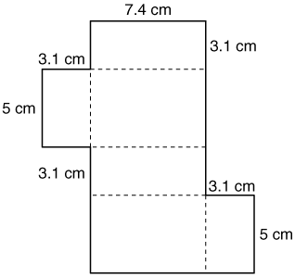

- Find the total surface area of the triangular prism:

