Turner Middle School
Lady Basketball
2014 – 2015
Parent Information Packet

Date | Opponent | 7th Girls | 8th Girls | 7th Boys | 8th Boys
Nov 20 | Factory Shoals | H 4:30p | H 5:30p | A 4:30p | A 5:30p
Nov 21 | Fairplay | A 4:30p | H 4:30p | A 5:30p | H 5:30p
Dec 4 | Chestnut Log | A 4:30p | A 5:30p | H 4:30p | H 5:30p
Dec 5 | Yeager | A 4:30p | H 4:30p | A 5:30p | H 5:30p
Dec 9 | Chapel Hill | A 4:30p | A 5:30p | H 4:30p | H 5:30p
Dec 12 | Mason Creek | A 4:30p | H 4:30p | A 5:30p | A 5:30p
Dec 16 | Stewart | H 4:30p | H 5:30p | A 4:30p | A 5:30p
Jan 9 | Factory Shoals | A 4:30p | A 5:30p | H 4:30p | H 5:30p
Jan 13 | Fairplay | H 4:30p | A 4:30p | H 5:30p | A 5:30p
Jan 16 | Chestnut Log | H 4:30p | H 5:30p | A 4:30p | A 5:30p
Jan 22 | Yeager | H 4:30p | A 4:30p | H 5:30p | A 5:30p
Jan 23 | Chapel Hill | H 4:30p | H 5:30p | A 4:30p | A 5:30p
Jan 27 | Mason Creek | H 4:30p | A 4:30p | H 5:30p | A 5:30p
Jan 30 | Stewart | A 4:30p | A 5:30p | H 4:30p | H 5:30p
TMS Basketball Schedule
2014 - 2015

Practice Schedule
Tuesday, February 3rd 7th Grade Playoffs: Games will be played at the Higher Seed’s school

Wednesday, February 4th 8th Grade Playoffs: Games will be played at the Higher Seed’s school

Thursday February 5th 7th Grade Semi-Finals: Games will be played at YMS

Friday February 6th 8th Grade Semi-Finals: Games will be played at YMS

Saturday February 7th 7th and 8th Grade Championships: Games will be played at YMS
Turner has one gym and four teams; the girls and boys basketball teams share the gym,
so we alternate having practice weekly from 3:45p – 5:30p & 5:30p – 7:30p.

Coach Kennedy will host an hour long study hall for the ladies each late practice day.
*Please ensure your daughter has snacks, & please pick up your daughter on time.*

(Opportunities for additional practice/skill development will be available.)

Week of November 3 Practice Ends at 5:30p
Week of November 10 Practice Ends at 7:30p
Week of November 17 Practice Ends at 5:30p

Week of November 24 Voluntary Practice w/ Mrs. Richards Time(s) TBD

Week of December 1 Practice Ends at 7:30p
Week of December 8 Practice Ends at 5:30p
Week of December 15 Practice Ends at 7:30p

Week of December 22 & 29 Voluntary Practice w/ Mrs. Richards Time(s) TBD

Week of January 5 Practice ends at 5:30p
Week of January 12 Practice Ends at 7:30p
Week of January 19 Practice Ends at 5:30p
Week of January 26 Practice Ends at 7:30p
Week of February 2 Practice Ends at 5:30p
Transportation Volunteers Needed
The Lady Indians do not have a bus and need help transporting girls to games. Please volunteer, if you can. Write your name next to the date(s) you are willing to help. Thank you!
I can transport 4 girls, which leaves six 7th graders who need rides to the away games.
Date | Your Name and Number of Ladies You Can Transport
Friday November 21st  Leaving at 3:30p  2 cars needed  Fairplay | Ex: Coach Kennedy | 4
Thursday December 4th
Leaving at 3:45p
2 cars needed
Chestnut Log
Friday December 5th
Leaving at 3:45p
2 cars needed
Yeager
Tuesday December 9th
Leaving at 3:45p
2 cars needed
Chapel Hill
Friday December 12th
Leaving at 3:45p
2 cars needed
Mason Creek
Friday January 9th
Leaving at 3:45p
2 cars needed
Factory Shoals
Friday January 30th
Leaving at 3:45p
2 cars needed
Stewart
Tuesday February 3rd
Possibly leaving at 3:45p
2 cars needed
Playoffs - TBD
Thursday February 5th
Leaving at 3:45p
2 cars needed
Playoffs - Yeager
Saturday February 7th
Leaving at 3:45p
2 cars needed
Playoffs - Yeager
Eligibility & Fees

Eligibility: Fall 2014 current 7th and 8th grade TMS students are eligible to play. Students can get no more than 1 failing grade for the semester to maintain eligibility throughout the year.

Equipment: There will be a $75.00 fee. This will go towards basketball equipment and other miscellaneous products. Players will be provided a warm up suit, a t-shirt and a bag for participation. However, they must purchase their own mid top or high top black basketball shoes.

Uniforms: A uniform will be assigned to each player for the season. Players are responsible for the upkeep of their uniforms (unless a coach takes it). Any damages that occur to the uniform will result in a $100.00 fee. *Avoid putting the uniform in the dryer; try air drying it. A player missing a uniform on game day will not play.

I (parent) _______________________ and (player) _______________________ agree to pay a sum of $100.00, if the assigned uniform is lost or damaged in any shape, form or fashion. This includes unauthorized alterations.

Signed Name: _______________________ Date: _______________________

Insurance Information
Basketball is a highly competitive sport that usually results in injury. Therefore, your child having proper insurance coverage is critical to help protect her in the event that she becomes injured participating in any related basketball activity.

*If you are going to use your personal insurance, please check the appropriate statement below as well as fill in the blanks.
______ I (parent) _______________________ will provide insurance coverage for (player) _______________________ in the event that she becomes injured due to normal activity with regard to any basketball related activity.

Insurance Company ___________________ Policy Number _________________

*If you would like to purchase school insurance, please check the appropriate statement and fill in the blanks.
______ I (parent) _______________________ would like to purchase school insurance for (player) _______________________ in the event that she becomes injured due to normal activity with regards to any basketball activity.

Emergency Procedures
Please check one of the following two statements:
_____ In the event (player) _______________________ is injured during a game or practice, and I cannot be reached, I permit the school to use judgment and proceed with emergency procedures with my consent.
_____ I do not give my consent for emergency procedures to take place, if I am not present.
Name: _______________________ Date: _______________________

Travel Permission

_____ I give (player) _______________________ consent to travel in a motor vehicle of a coach, teacher or other parent, if I am unable to transport my daughter to and from practices and games.
_____ I do not give consent for my child to travel in another motor vehicle. I will assume all responsibilities for getting her to and from practices, games, basketball related functions, etc. … I understand that without this consent, my daughter will not be able to participate in away practices, games and functions, if I cannot take her.
Name: _______________________ Date: _______________________

Contact Information (For Coaches Only)

Parent Name: ______________________________________________
Player Name: _______________________________________________
Phone Number: _____________________________________________
Address: ___________________________________________________
Email Address: ______________________________________________

Parent Phone Tree
It has been helpful for parents to share their information with others on the team to help with transportation to and from practice and games, coordinating snacks or finding substitutes for a shift that can no longer be filled. If you would like to share a contact number and/or address for parents to contact you, please fill in the parts of the form below you would like to share. Thanks!

Name: ___________________________________________
Name & Grade of Player: _________________________
Phone Number: ___________________________________
Address: __________________________________________
___________________________________________________

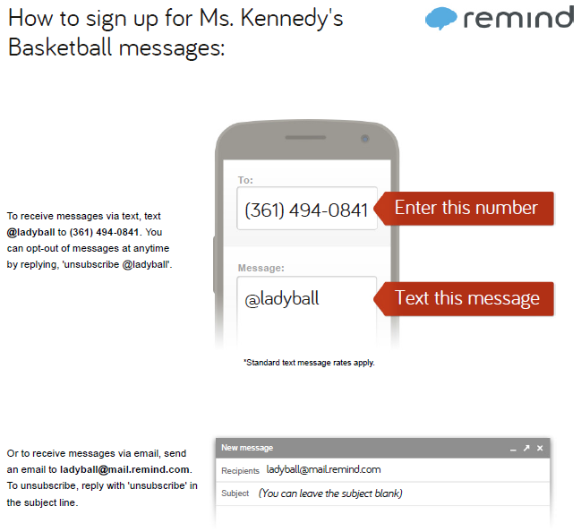

Parent Check List
I have completed the following:
_____ I paid the $75 dues.*
_____ I purchased black basketball shoes.*
_____ I reviewed the Game & Practice Schedules.*
_____ I volunteered to provide transportation and/or to man the concession.
_____ I signed up for Remind101 to get notifications & reminders from the coaches.*
_____ I read, understood and completed the Eligibility & Fees Form.*
_____ I read, understood and completed the Insurance Form.*
_____ I read, understood and completed the Emergency Procedures Form.*
_____ I read, understood and completed the Travel Permission Form.*
_____ I read, understood and completed the Contact Information Form.*
_____ I shared contact information for the Phone Tree.
_____ I have returned the Transportation Volunteer Form, Concession Stand Volunteer Form, Eligibility & Fees Form, Insurance Form, Emergency Procedures Form, Travel Permission Form and Contact Information Form to the coach and kept the schedules, coach contact information & check list.*

*Mandatory

