Select the correct response.
1. Does the mean or median best describe a typical value in the data set shown?
19, 18, 19, 18, 19, 19, 1, 19, 18, 19, 18
Mean
Median
Neither describe a value in the
data well.
Both describe a value in the
data well.
2. The dot plot shown displays the heights, in inches, of the students in one class. Which measure of variability best describes how spread out the heights of the students are?
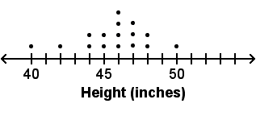
Mean
Median
Mean absolute deviation
Interquartile range
3. The exam scores from the most recent math test are shown. What is the value of the measure that best describes a typical exam score? Round your answer to the nearest whole number.
93, 88, 76, 91, 92, 96, 100, 96, 74, 89, 94, 91

90
91.5
96
100

Answers on next page
4. What measure best describes the variability of the data set displayed using the box plot shown?
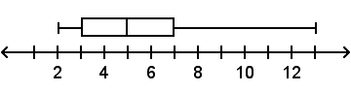
Mean
Median
Mean absolute deviation
Interquartile range
5. The number of miles Cynthia travels each day is shown. What are the values of the measures of center and variability that best describe the data set?
57, 40, 35, 60, 56, 57, 59

The mean 52 miles and the mean absolute deviation about 8 miles
The median 57 miles and the interquartile range 19 miles
The mean 57 miles and the mean absolute deviation 19 miles
The median 52 miles and the interquartile range about 8 miles
Select all correct answers.
6. Which measures of center and variability best describe the data set shown?
17, 19, 15, 12, 10, 21, 2, 16, 18, 19, 20, 16, 11, 12, 17

Mean
Median
Mode
Mean absolute deviation
Interquartile range
Range

Answers
1. B
2. C
3. B
4. D
5. B
6. B, E

