Human Battleship
Purpose:
Formatively assess student understanding of the standards herein through kinesthetic engagement in a human form of the game Battleship!

Standards:
MCCS.6.NS.6b Understand signs of numbers in ordered pairs as indicating locations in quadrants of the coordinate plane; recognize that when two ordered pairs differ only by signs, the locations of the points are related by reflections across one or both axes.

MCC6.NS.6c Find and position integers and other rational numbers on a horizontal or vertical number line diagram; find and position pairs of integers and other rational numbers on a coordinate plane.

MCC6.NS.8 Solve real‐world and mathematical problems by graphing points in all four quadrants of the coordinate plane. Include use of coordinates and absolute value to find distances between points with the same first coordinate or the same second coordinate.

Physical Materials Needed:
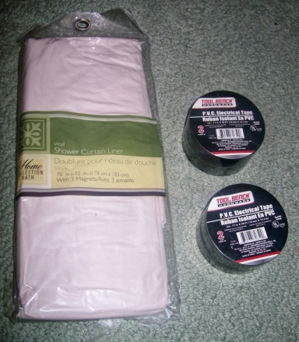
Coordinate Grid:
White Plastic Shower Curtain (x 2)
Rolls of electrical tape (x 4)
Or
Rope/Yarn & Tape
Or
Tiles on the floor
Divider:
Fabric
Or
Butcher Paper
Yard Stick (x 2)

Pre-Game Set - Up:
1) Two quadrants of the coordinate plane should be created using the shower curtain and electrical tape (recommend each square measure 1 sq ft).

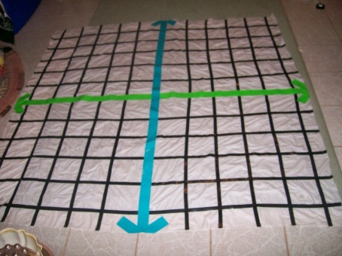
2) Place the quadrants adjacent to each other with fabric in between the two quadrants acting as a barrier.

3) Create two teams.
Each team needs to determine:
A. a team name

B. in which quadrant they want to place their 'ships.'

C. a funny phrase to taunt the other team for missing their 'ship.'

D. a funny phrase to taunt the other team when hitting their 'ship.'
E. a Submariner - Records which coordinates have been called by each team and which of those hit and miss.

F. a Sound Off Person - Preps the team to shout their phrase to the other team.

4) Assign three people to hold the fabric (one on each end and one in the middle, if needed).

Actual Game Board Set - Up:
1) Students will stand in lines of 3, 4 & 5 (depending on size of team) on their quadrant of the coordinate plane. These are the 'ships.' No horizontal lines or boats of 1 or 2.

2) The Submariner for each team will record the coordinates of each of the 'ships.' - Format is on the handout.

3) Each student is made aware of his/her coordinate pair on the coordinate plane. - It must align with the quadrant the team chose.

Playing the Game:
Either arbitrarily or individually, the teacher will choose a person from one team to shoot a missile at the other team's ships (i.e. call out a coordinate pair where they believe a 'ship' may be located).

The coordinate is recorded by each Submariner.

The attacked team's will indicate whether they have been hit or not. The student should be aware of his/her location, but the Submariner of the other team can double check his/her list.

It's A Miss:
If the attacked team has not been hit, the attacked team's Sound Off person will engage the team in calling out their 'You Miss' phrase, and someone from their team begins the 'missile launching' process.

This will continue back and forth until a 'ship' gets hit.

It's A Hit:
If the attacked team has been hit, the attacking team's Sound Off person will engage the team in calling out their 'Hit You' phrase and the person hit steps off the grid.

The attacking team will keep their turn and 'launch another missile' (i.e. call out another coordinate pair). This will continue until they miss.

(OVER)
Assessment:
As students choose their coordinate pairs, the teacher will be able to assess whether the student understands how to maneuver around the coordinate plane.

*Are the students calling out the correct signs for the opposing teams quadrant?
Incorrect signs automatically mean a miss!

*Are the students calling out coordinate pairs that are in line with the previously successful coordinate pair?
The next coordinate pair called should differ + 1 from the previous coordinate pair either in the x or y position.

Ex: (2, 4) is a hit.
The next coordinate pair called should be (2, 3), (2, 5), (1, 4) or (3, 4).

* If the student calls out a coordinate pair completely different than the previous successful coordinate pair, individual remediation will be needed.

OPTIONAL: Students tend to forget their coordinate pair. Have them record it on a small slip of scratch paper and keep it with them during the game.

