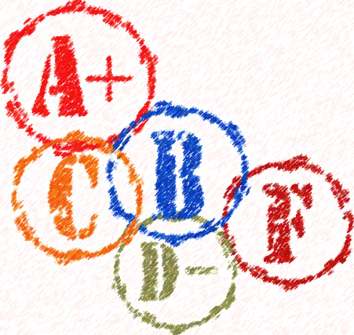
Lady Indian: _________________________ Date: November 21, 2014
Subject | Grade | Behavior | Teacher Signature
1. |  | NI G E
2. |  | NI G E
3. |  | NI G E
4. |  | NI G E
5. |  | NI G E
6. |  | NI G E
7. |  | NI G E

Lady Indian: _________________________ Date: December 05, 2014
Subject | Grade | Behavior | Teacher Signature
1. |  | NI G E
2. |  | NI G E
3. |  | NI G E
4. |  | NI G E
5. |  | NI G E
6. |  | NI G E
7. |  | NI G E

Lady Indian: _________________________ Date: December 12, 2014
Subject | Grade | Behavior | Teacher Signature
1. |  | NI G E
2. |  | NI G E
3. |  | NI G E
4. |  | NI G E
5. |  | NI G E
6. |  | NI G E
7. |  | NI G E

Lady Indian: _________________________ Date: December 19, 2014
Subject | Grade | Behavior | Teacher Signature
1. |  | NI G E
2. |  | NI G E
3. |  | NI G E
4. |  | NI G E
5. |  | NI G E
6. |  | NI G E
7. |  | NI G E

Lady Indian: _________________________ Date: January 16, 2015
Subject | Grade | Behavior | Teacher Signature
1. |  | NI G E
2. |  | NI G E
3. |  | NI G E
4. |  | NI G E
5. |  | NI G E
6. |  | NI G E
7. |  | NI G E

Lady Indian: _________________________ Date: January 23, 2015
Subject | Grade | Behavior | Teacher Signature
1. |  | NI G E
2. |  | NI G E
3. |  | NI G E
4. |  | NI G E
5. |  | NI G E
6. |  | NI G E
7. |  | NI G E

