DECIMAL OPERATIONS

Add or Subtract Decimals:
Line up the place values. Use place holders, if necessary.

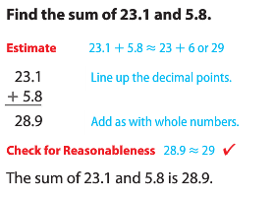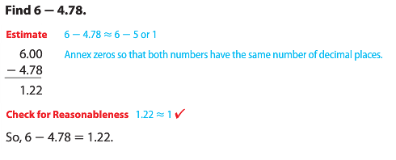
Multiply Decimals:
Add up the total number of place values behind the decimal in each factor. Your product should have the same total number of place values behind the decimal.

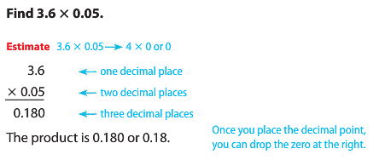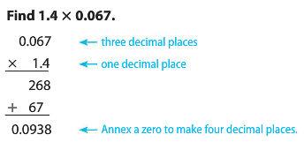
Divide Decimals:
Multiply the divisor by the necessary power of 10 to make it whole. Then, multiply the dividend by the same power of 10. Then, divide.

