CONSTRUCTED RESPONSE: 6.NS.5

1. Express each of the following situations as a signed (positive or negative) number or zero.

a. An airplane at an altitude of 30,000 feet

b. A submarine at a depth of 1,200 feet

c. A boat on the surface of the ocean

2. Use a signed number to represent each of the following situations. **Then** describe what 0 represents in the same situation.

a. Salazar dives to a depth of 73 feet.

b. Nu deposits $16.78 into her bank account.

c. Overnight, the temperature drops by 15 °F.

3. Write a situation that could be described by each of the following integers.

a. 50

b. -50

CONSTRUCTED RESPONSE: 6.NS.6a, 6.NS.6b6.NS.6c

4. Johanna is standing on a hillside 35 feet above sea level, and Marcus is exploring a cave at an elevation that is the opposite of Johanna’s elevation. What is Marcus’s elevation?

Select the correct answer.

5. Where is  on a number line? Why?

CircleA_M13EAN Between -3 and -2

CircleB_M13EAN Between -1 and 0

Description: CircleC_M13EAN Between 0 and 1

* Between 2 and 3

Explain your answer:

\_\_\_\_\_\_\_\_\_\_\_\_\_\_\_\_\_\_\_\_\_\_\_\_\_\_\_\_\_\_\_\_\_\_\_\_\_

\_\_\_\_\_\_\_\_\_\_\_\_\_\_\_\_\_\_\_\_\_\_\_\_\_\_\_\_\_\_\_\_\_\_\_\_\_

\_\_\_\_\_\_\_\_\_\_\_\_\_\_\_\_\_\_\_\_\_\_\_\_\_\_\_\_\_\_\_\_\_\_\_\_\_

6. Graph -5, 0, 2, and 4 on the number line. Then, graph their opposites on the same number line.



Select the correct answer.

7. Where is  on a number line? Why?

CircleA_M13EAN Between -3 and -2

CircleB_M13EAN Between -1 and 0

Between 0 and 1



* Between 2 and 3

Explain your answer:

\_\_\_\_\_\_\_\_\_\_\_\_\_\_\_\_\_\_\_\_\_\_\_\_\_\_\_\_\_\_\_\_\_\_\_\_\_

\_\_\_\_\_\_\_\_\_\_\_\_\_\_\_\_\_\_\_\_\_\_\_\_\_\_\_\_\_\_\_\_\_\_\_\_\_

\_\_\_\_\_\_\_\_\_\_\_\_\_\_\_\_\_\_\_\_\_\_\_\_\_\_\_\_\_\_\_\_\_\_\_\_\_

Select all correct answers.

8. What numbers are graphed on the vertical number line?

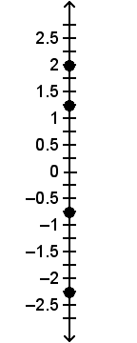

CircleA_M13EAN -2.5 Description: CircleC_M13EAN 1

CircleB_M13EAN -2.25 Description: CircleC_M13EAN 1.25

CircleC_M13EAN -1.75 Description: CircleC_M13EAN 2

CircleD_M13EAN -0.75 Description: CircleC_M13EAN 2.5

9. Graph & label (0.75, -1.25), (1.5, 2), (-0.25, -1.75), and (-1, 0.75).

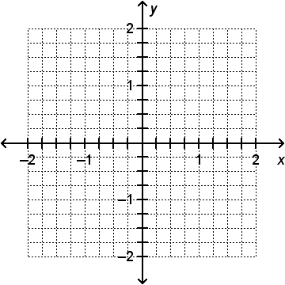

10. Below is a map showing various places in relation to Carlos’s house at the origin. Find the coordinates of the library, the school, the bike shop, and the baseball field.

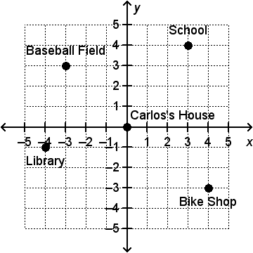

CONSTRUCTED RESPONSE: 6.NS.7a

11. Describe the positions of 10 and 17 relative to each other on a number line in two different ways, given that 17 > 10.

6.NS.7b

Select all correct answers.

12. Jack needs a piece of wood at least   
 inch long for some detail work on a project he is working on. Which of the following lengths of wood would meet   
his requirements?

CircleA_M13EAN  inch

CircleB_M13EAN  inch

CircleC_M13EAN  inch

CircleD_M13EAN  inch

Description: CircleC_M13EAN  inch

CONSTRUCTED RESPONSE: 6.NS.7b

13. A recipe calls for  cup strawberries,   
 cup sugar,  cup walnuts, and  cup flour. Order the amounts from least to greatest. Which ingredient does the recipe require the least amount of?

6.NS.7c, 6.NS.7d

14. Which of the following pairs of numbers have the same absolute value?

CircleA_M13EAN -1, 0.1

CircleB_M13EAN , 

CircleC_M13EAN 0, 1

CircleD_M13EAN -4, -40

15. How do the numbers -3 and 2 compare? How do their absolute values compare?

CircleA_M13EAN -3 is greater than 2, but 2 has the greater absolute value.

CircleB_M13EAN 2 is greater than -3, but -3 has the greater absolute value.

CircleC_M13EAN -3 is greater than 2, and -3 has the greater absolute value.

CircleD_M13EAN 2 is greater than -3, and 2 has the greater absolute value.

CONSTRUCTED RESPONSE:

6.NS.7c, 6.NS.7d

16. Monica is hiking in California’s Death Valley. Along her route, she sees a sign that says “282 feet below sea level.”

a. What is the elevation of the sign? Explain.

b. How far up or down must Monica hike from the sign to reach sea   
level? Explain.

CONSTRUCTED RESPONSE

6.NS.8

Select the correct answer.

17. Point A is located at (-3, 1), point B is located at (-3, -4), and point C is located at (3, 1) on a coordinate plane.

a. What is the distance between points A and B?

b. What is the distance between points A and C?

18. On a coordinate plane, point A is located at (-5, 3). To get to point B, move 8 units to the right, 6 units down, and 1 unit to the left. What are the coordinates of point B?

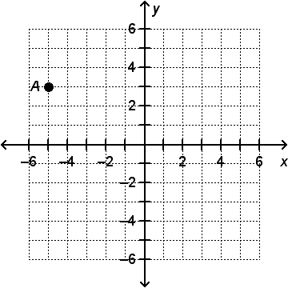

CircleA_M13EAN (-12, 9)

CircleB_M13EAN (-12, -3)

CircleC_M13EAN (2, -3)

CircleD_M13EAN (2, 9)