Miniature Golf - Statistics
Purpose:
Provide a DOK 4, real world context for students to learn how to collect, describe, represent and analyze data through miniature golf.

Standards:
MCCS.6.SP - All

MCC7.SP 1 - 4

MCC8.SP - All

Physical Materials Needed:
Golf Clubs or sticks/poles, etc.
Golf Balls or tennis balls, basketballs, etc.
Holes
Dug in the ground, baskets, Styrofoam cups, etc.

Play (Collect Data):
1) Create 1 – 3 holes.

2) Have each student or a small group of students putt for each hole.

3) Have remaining student record how many strokes it takes players to get the ball into the hole and cheer efforts.

4) Optional: Take pictures of the students playing.

Represent Data:
1) Students will determine par from each hole based on the players’ strokes.

2) Students will then represent each player’s deviation from par.

3) Remaining applicable statistics required by standards will be represented (i.e. mode, median, etc.)

4) Students will create box & whisker plots, histograms, dot plots, scatter plots, etc.

Describe Data:
In small groups, students will describe the data.

(OVER)
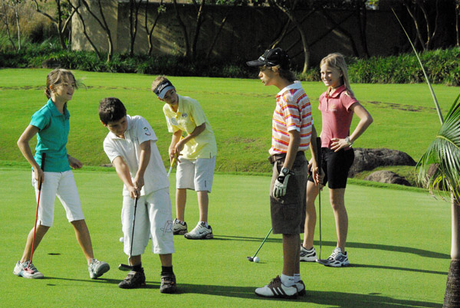

Analyze Data – 6th, 7th & 8th Grade:
6th: Teachers will help students draw conclusions about the data.
7th & 8th: In small groups, students will draw conclusions about the data as applicable to their standards.
Illustrate:
The attacked team's will indicate whether they have been hit or not. The student should be aware of his/her location, but the Submariner of the other team can double check his/her list.

Illustrate:

Students in their small groups will creatively present their collection of data, tables and graphs, descriptions and conclusions in some manner (poster board, power point, video, etc.). Optional: The pics taken during the golfing can be used here, as well.

Assessment:
Teachers will grade for adherence to procedure, accuracy of results and aesthetics.

